**El monstruo “FUYJI “**

*“Z” verbs don’t use “Z” accents!*

*To find the Z endings connect the regular endings in the belly of the monster to form a Z (with a tail)*

*In the U- Uv, J & I boxes, write the verb infinitives +irregular stems. *In the rest, write the infinitives*.

**U&u**v **z-verbs**

**Regular endings**

**Accent Happy!**



**Y-SOLE**

*Draw 5* eyelashes

*estar → estuv-

**Regular endings Accent Happy!**



**f**u**-fU Totally Irregular-No accents**

*List 6 verbs and* ***then******conjugate one***

*What are the 2?*

*______ ______*

***Now conjugate***

**Regular endings**

*hacer → hic- (hizo)

-ER/-IR

-AR

**-í**

**-iste**

**-ió**

**-imos**

**-isteis**

**\*-ieron**

**-é**

**-aste**

**-ó**

**-amos**

**-asteis**

**-aron**

**JZ-verbs**

**\*they don’t like them “i”s **

I z-verbs

**Fraternal Twins**

**-gemelos desnudos**

(No Accents)

* decir → dij-

**Pirata**

**Regular Endings **

**Irregular “yo”**

**-zar**

Yo - cé

**-gar**

Yo -gué

**-car**

Yo -qué

**Sole verbs**

**Regular Endings**

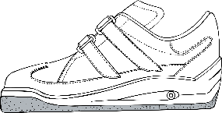

Only shoe verbs that end in **“IR**”

o-u e-i