Cuando éramos niños
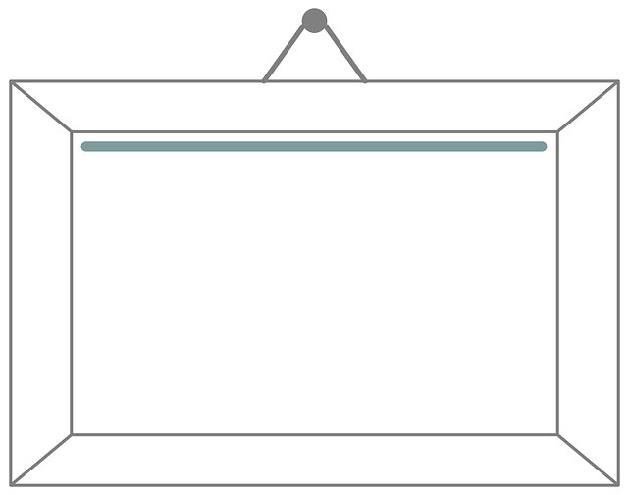
Please write your two paragraphs below, then have someone peer edit it.
For this speaking assignment, you will memorize information about your childhood. In the first part, you will talk about what you were like as a child and in the second part, you will talk about your vacations. (You can always be creative on the information you’re telling us!)
In order to get an A you must use a variety of vocabulary, use the imperfect at least 8 times correctly, talk about both parts mentioned above and you will need to include 3 (max. 5) photos as well.
And, of course, it must be memorized and completed on time!
Right before you record your presentations, you will turn this paper in. Once done, you will upload it to google classroom!

________________________________________________________________________________________________________________________________________________________________________________________________________________________________________________________________________________________________________________________________________________________________________________________________________________________________________________________________________________________________________________________________________________________________________________________________________________________________________________________________________________________________________________________________________________________________________________________________________________________________________________________________________________________________________________________________________________________________________________________________________________________________________________________________________________________________________________________________________________________________________________________________________________________________________________________________________________________________________________________________________________________________________________________________________________________________________________________________________________________________________________________________________________________________________________________________________________________________________________________________________________________________________________________________________________________________________________________________________________________________________________________________________________________________________________________________________________________________________________

Have someone read your paragraphs and edit them.
Rubric: (20 points) This part is to be used for peer/self-editing. Peer editor: ______________________

 | Score | Comments
Requirements: 2 paragraphs, neatly written, evident that hand written notes were used as well as vocabulary that we studied
Grammar: used the imperfect correctly according to the subject/ Used the IOP correctly
Fluency: Clearly written, logical information -Talked about childhood and vacations
Accuracy: Adjectives describe nouns, correct word placement (nouns then adj, / Iop’s before verbs, etc..) correct use of grammar and spelling
Vocabulary: used a variety/ good word choice

4-Distinguished 3-Well done/few errors 2-Good, but errors affect comprehension 1-Needs improvement

Have someone listen to you talk about your childhood and have them grade you!
Speaking Rubric for Chapter _4A/B_: Topic: Childhood: favorite toy - vacation
Peer Editor: _____________________
 | Amazing | Proficient | Developing | No substantial evidence
Vocabulary- A wide variety (this chapter and previous)? Original sentences? New vocabulary gained outside of class? | Original  Wide variety | sufficient | Limited vocab | English used
Grammar-- Minor and limited spelling and grammar errors. Are your sentences grammatically correct? Adjectives agree with nouns? Use of words like “gustar”- (A mí me gusta(n)…)  Verbs- Are you using them correctily? | Limited minor errors | Overall meaning conveyed  Minor errors | Errors affect/hinder comprehension | Severely affects comprehension
Content- Fulfills prompt and adds details to support prompt?  Tense: Imperfect  Childhood Vacation | Adds details  8 imperfect | Fulfills  6 imperfect | Does not fulfill  Tried imperfect | Does not address
Structure- Organized in a logical manner, Varied sentence structure, creates statements and asks questions, transitions, format  **IOP ___ | Logically organized/ | Somewhat organized/ overall correct | Organizations is week/repetitive/limited | No organization
Comprehensibility - mastery of Spanish accent, appropriate pauses, errors never prevent communication, self-corrects  ** Used pictures to help with understanding? Child Toy Vacation  3-5 photos | Errors never prevent communication -self-corrects | Few errors, short unnecessary pauses | Major errors, pauses are distracting | Errors severely affect comprehension
** WOW! Introduced prompt, Creative, Cultural Conn.- Bring fav toy 100 | 90 ↑ | 80 ↑ | 70 ↑ | 60 ↑

How many sentences were memorized? __________ Memories?_____ Vacation? ____ How many times was the imperfect used correctly? _______________

